a. (1 point) Since there are three numbers, supposedly chosen at random, about what percentage of each sequence should be 1’s? 2’s? 3’s?
Let’s check! What percent of the digits in Sequence #1 are
b. (1 point) 1’s?
There are 8 1’s in this sequence, so divide 8 by 20 and multiply by 100 to get the percentage
8/20 x 100 = 40%

c. (1 point) 2’s?
There are 7 2’s in this sequence, so
7/20 x 100 = 35%

d. (1 point) 3’s?
There 5 3’s in this sequence, so
5/20 x 100 = 25%

What percent of the digits in Sequence #2 are
e. (1 point) 1’s?
There are 4 1’s in this sequence, so divide 4 by 20 and multiply by 100 to get the percentage
4/20 x 100 = 20%

f. (1 point) 2’s?
There are 9 2’s in this sequence, so
9/20 x 100 = 45%

g. (1 point) 3’s?
There are 7 3’s in this sequence, so
7/20 x 100 = 35%

Well, shoot – only one of them is even close to your answer in a! Darn it!
MOE = z * √p * (1 - p) / √n
Where:
MOE is the margin of error,
z is the z-score associated with a level of confidence,
p is the sample proportion, expressed as a decimal,
n is the sample size,
N is the population size.

Z-Score Formula
The Z-Score uses the following formula:
z = (x - μ) / σ
Where:
z is the standard score or Z-score,
x is the raw score to be standardized,
μ is the mean of the population,
σ is the standard deviation of the population.

We need to first find the mean and standard deviation to able to get the z-score and margin of error (MOH).
Mean for sequence #1 is 1+2+1+3+1+2+1+2+1+2665655+1+2+3+1+2+3+1+3+2+3 = 37/20 = 1.85
Mean for sequence #1 is 1+3+1+2+2+2+2+3+3+3+2+1+1+2+3+3+2+2+2+3 = 43/20 = 2.15

But wait! We’re forgetting something important!
We need a margin of error on those statistics! Those 20 numbers are only a small sample of all possible random numbers Jenny could have called – that means their percentages will have some wiggle room (even calling them “percentages” is a stretch, since there are only 20 of them. 😊😊). And, since the sample is so small (20), it’s gonna be quite a bit of wiggle! In fact, it’s about 15%!

Let’s use that MOE for the statistics you collected above to fill in the blanks!
h. (2 points) Jenny is calling between _36.5%___ % and ___43.5%___% 1’s in Random Sequence #1.
i. (2 points) Jenny is calling between __31.75%___ % and _38.25%__% 2’s in Random Sequence #1.
j. (2 points) Jenny is calling between __23.5%__ % and __26.5%____% 3’s in Random Sequence #1.
k. (2 points) Jenny is calling between __19.34%__ % and __20.66%__% 1’s in Random Sequence #2.
l. (2 points) Jenny is calling between __41.22%__ % and __48.88%___% 2’s in Random Sequence #2.
m. (2 points) Jenny is calling between _29.67%__ % and __40.33%__% 3’s in Random Sequence #2.
Rad! Unfortunately, that didn’t help us tease out the non-randomness of either sequence; since the percentage you got in a is within all of those ranges of values for each digit in both sequences, we can’t say she deviated too much in either one from “the number of 1’s, 2’s and 3’s she should have randomly said”.
Hmmmm…go back and take a look at those sequences again – does anything else jump out at you right now? If so, great! If not – let’s take a look at some more “truly random” sequences in Excel23456 !

Open up a blank Excel document (make sure you don’t have any others opened).
• Pick any old cell you like and type the formula =randbetween(1,3)
• Press Enter. In that cell you’ll now see a random digit, between 1 and 3. Rad! If you press the button, you’ll get a
new one. Press it a bunch of times! More fun!
• Drag that formula over so that you get a row of 20 random numbers (like our sequences up there).
• Press a bunch until you can answer the question below!
n. (5 points) Compare the sequences that you’re getting in your spreadsheet now with the two original sequences that started this question! Which one of those two most closely resembles the truly random sequences you’re generating, and why doesn’t the other one show that characteristic?
These are generated from excel
1 | 1 | 2 | 1 | 2 | 1 | 1 | 3 | 1 | 2 | 2 | 1 | 1 | 1 | 1 | 2 | 1 | 2 | 3 | 2

Random Sequence #1 closely resembles the generated sequence. This is because it’s margin of error is larger meaning it does not rely on the previous number to generate the next number.

o. (5 extra points) (w) What’s the chance that the other sequence (that is, the one you didn’t think was random enough, based on criteria you used in the last question) was truly random?
There is a 0.5 chance that this sequence was also random because the numbers did not follow a certain order.

2. In “class”, we discussed the average rate of inflation of COCC’s tuition over a period of time. And, after that discussion, you may have felt a bit peeved. “How come we have to pay so much for tuition? Our tuition went up WAY faster than inflation!!! What gives? I have a buddy at (insert Oregon community college here) who actually pays less than we do at COCC – why?8” In this question, I want to break down those concerns, and also give you one more skill that you can use to measure financial quantities more effectively!
I went online and gathered up as much data as I could9 about all the Oregon community college tuitions; it’s in the
spreadsheet for this question (note: to keep it simpler, I only used in-district tuition). Use that data to answer the following!
- (3 points) Where did COCC rank (1 through 17, “1” being “most expensive”) in 2014?
13
- (3 points) Where did COCC rank (same ranking system) in 2019?
10
Ah, so we’re “middling in the ranks”. Bummer! But, we’re still in the bottom half, so I’m feeling pretty good.
Oh! But wait! We forgot to adjust for cost of living in those various places! I used this tool to do just that – click on over to
the other tab (“adjusted tuition”). Now, it’s not perfect, but I used the “overall” cost of living to adjust the tuition cost so that
everything is in “Bend Dollars”. Here’s how I figured it, using Pendleton (hometown of Blue Mountain Community College) as an
example:

So that means that things in Pendleton only cost 70% of what they do in Bend. As an equation, that would look like this:
Cost of Something in Pendleton =70/100 *(Cost of That Same Thing in Bend)

Or, said a different way:
100/70 * (Cost of Something in Pendleton) = Cost of That Same Thing in Bend
So, for Pendleton, I multiplied all the tuitions in their unadjusted list by about 1.42 to get what their tuition should have
been each year. Like this:

2014 2015 2016 2017 2018 2019
Blue Mountain (unadjusted) $90.00 $94.00 $96.00 $103.00 $108.00 $108.00
Blue Mountain (adjusted) $128.57 $134.29 $137.14 $147.14 $154.29 $154.29

I then did the same thing for all the other towns in the list, an that’s what you see in that sheet!
- (3 points) Using these more “apples/apples” data, where did COCC rank (1 to 17, with, again, 1 being most expensive) in2014?

15

- (3 points) How about in 2019?

17

Yay! I feel much better!
- (5 points) Which colleges are in cities that have a higher cost of living than Bend (according to these new data)? Note: you don’t need to do any research about these towns, or even know which towns they are – the spreadsheet math tells you all you need to know.
Clackamas, Portland, Central
f. (10 points) Using either data set (adjusted or not), create a graph showing all 17 community colleges’ tuitions changing year to year across this time range. Make sure to label your axes if Excel doesn’t automatically do it for you. Give your graph a good title – and please: make sure that COCC’s tuition stands out in some way from the others so it’s easy to spot!

3. Recently, I was chatting with a former MTH 105 student about life, and they brought up the ages of students in my class
and how young them seemed (all of you seem young to me, but I digress. 😊😊). In particular, this student mentioned
students “just out of high school”, and that sent me running to the COCC website to do some research. Let’s have you do
that, as well!
- (5 points) Start by visiting this COCC website, and find the number of COCC students in academic year 2019-2020 who graduated high school in 2019. It’s near the top of the page!
938
- (5 points) Now, use the most recent COCC Fact Book (you can find it by searching on the COCC site) to find the most recent “total credit enrollment” of COCC. Note: even though it’s the fact book from 2019-2020, it says (on page 13) “2017-2018.”
8732
- (5 points) Using those two numbers, what percent of COCC credit students are recent high school graduates?

938/8732 x 100 = 10.74%
OK! So, the vast majority of our students aren’t right out of high school. Cool! But that led me to asking, “Huh – just how
old are our students here at COCC?”

In the attached spreadsheet, you’ll see the results of my research. 😊😊Go ahead and open that up now!
- (5 points) For starters, create a time-series line graph representing this data! Years on the horizontal, ages on the vertical. Make sure your axes are labeled well, you have a good title, and (since there are two different data sets) a legend to differentiate the lie graphs. Screen shot it and place it here as your answer!

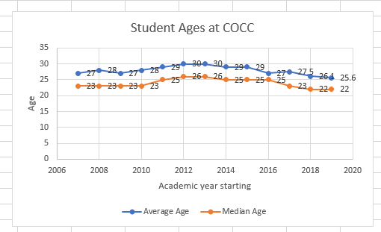
- (5 points) At this point, I think we’re all pretty sure how COCC was able to calculate the average age of COCC students (add up all the ages, and divide by how many students there are!). How did COCC find the median age? Write a couple of sentences!

The median is the middle value in a group of numbers. They first arranged the ages in order of magnitude from either the youngest to oldest or vice versa. Then looked for the number at the middle if the students are odd, or the mean of the middle two numbers if the number is even. Because the number of students is very large, it is easier to use the Median function of Excel to calculate for the median. MEDIAN(number1, [number2], …) where number1, number2 are the student’s ages.

- (5 points) You might notice that the average age of COCC students is always higher than the median age of the same students. Write a couple sentences to convince me why this makes sense, in general!

This show a right skewed distribution which means the ages after the median constitute of a larger sum than those lower than the median. This therefore will raise the value of mean and make it greater than the median.

4. For this last question, let’s actually revisit the point at which we started formally discussing probability in MTH 105. You might remember it as “that time I rolled a die 11 times but I thought I had rolled it 10.” Regardless of my counting problems, that was our first introduction to the wondrous and sometimes mind-bending world of measuring the unknown.
What made that experiment of rolling dice kinda fun was that we got interesting data in those first 11 rolls: two “gaps”, as I called them. That means that, of the 6 possible results I could have gotten when rolling a die multiple times, I didn’t see 2 of them. And some of us said, “That seems weird!” Let’s measure that weirdness. 😊😊
Start by opening the spreadsheet that accompanies this question. In it, you’ll see on similar to the one we used in class; however, in this one, I’ve coded it to count the number of gaps in each of the 11 rolls. You can watch the sheet update by pressing. What I’d like you to do first is to complete the “Cumulative %” column by supplying the proper Excel formulas. There are a couple of ways to do this; feel free to ask if you get stuck! Once you have that done, create a bar graph of the results of that column (with the “# of gaps” on the horizontal). Then, randomize the results until the bars in your graph stabilize!
- (4 points) Include a screen shot of your bar graph with stabilized data here!
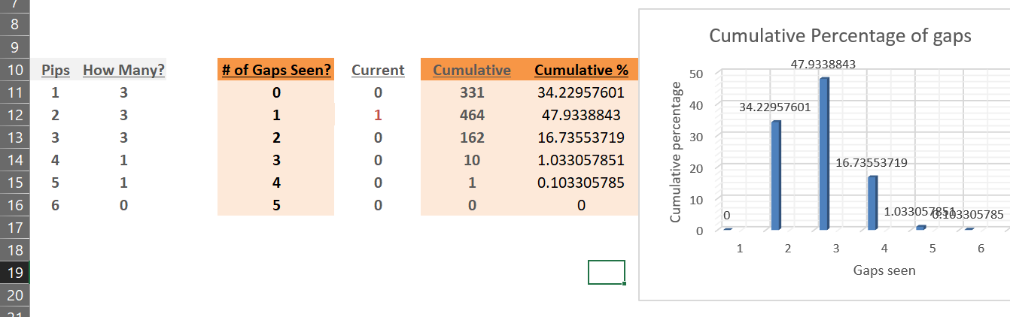

- (5 points) About what percent of the time should we see 2 gaps in 11 rolls of a die?
16.7355% as observed in the graph
c. (5 points) Based on your last answer, was it “weird” to see 2 gaps? Pease answer “yes” or “no” and then support your answer! For an extra credit point, answer it both ways with a convincing mathematical answer for each. 😊😊
No. Because there is a probability of any side to be observed because it is a fair roll.
Yes. The rolls are more to almost twice the number of expected sides to appear. So there is a very low chance of having two gaps.
d.(5 points) Calculate the average number of gaps that should appear in 11 rolls of a die (no need for work, as I’m assuming you’re using Excel to do this one).
(0 + 1 + 2)/3 = 1
Now you might remember (from that series of random videos) how excited I got when we saw this result right here:
I told our son about it, and he got really fired up. I mean, there is only about a
0.0024% of that happening10, after all.
But he asked me if I could keep the simulator running overnight, to try to get the “5
gaps” case. I smiled and told him “sure.11” And I did; you can see the results of my computer
working the simulator for 12 hours at right.
e. (extra 2 points) Assuming my computer can do the same number of trials as that
every 12 hours, about how many days will it take, on average, until we get the “5
gap” row to see its first entry?
Around 11 days

